Name: Emily Chiu

Lesson 9: Insert and Update

1. **Create** a table with the following parameters:
   * CustomerID
   * CustomerName
   * Address
   * City
   * PostalCode
   * Country
   * Email

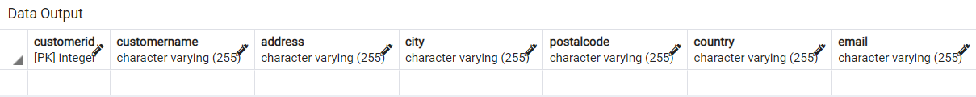

1. Insert 3 rows of data into these columns using **INSERT**. The data you insert should make sense for the column.



INSERT INTO information(customername, address, city, postalcode,country,email)

VALUES ('Paul','180 Ralph Avenue','Queens','12345','US','paulatralph@email.com'),

('Jen','123 1st Avenue','New York','11223','US','jen123@email.com'),

('Ben','5245 Palm Street','Miami','12354','US','palmsprings5245@email.com')

1. Use an **UPDATE** to modify any portion of the data

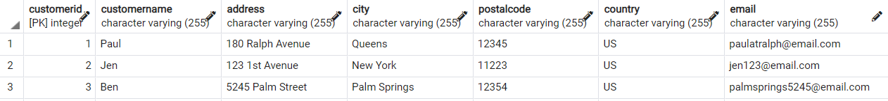

1. Finally, write a statement to **delete** one row of data.

